ER diagram and data base design
chat link
https://chatgpt.com/share/69ca0a05-0690-8320-b234-357a1af305d7
ER-diagram updated
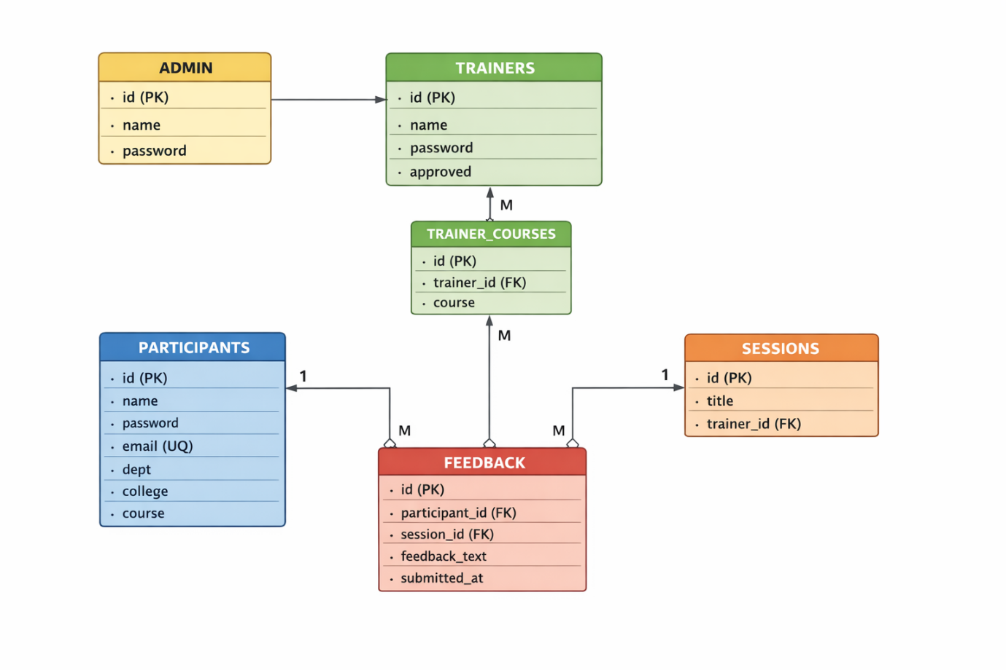
LUCICHARD AI
https://lucid.app/lucidchart/505f0c90-6be6-4889-9403-9ba29f2a7440/edit?viewport_loc=-991%2C-2010%2C3695%2C1721%2C0_0&invitationId=inv_745eb240-2e20-4df3-9a99-1539d96694e0
https://lucid.app/lucidchart/505f0c90-6be6-4889-9403-9ba29f2a7440/edit?viewport_loc=-991%2C-1797%2C3695%2C1721%2C0_0&invitationId=inv_745eb240-2e20-4df3-9a99-1539d96694e0

